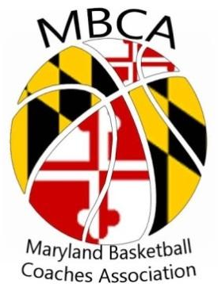
President: Teresa Waters
Vick President: John Brown
Treasurers: Annie McGaha
Secretary: Kathy Stoudt
Director of Public Information: Casey Rudzinski
Director of Collegiate Outreach: Rob Slopek
Director of Sponsorship: Barry Green

2017-2018
Membership Form

Membership Year
Until June 30, 2018

Name ___________________________________ School Name ____________________________________

Email (required) ___________________________ Classification of HS (1A, 2A, 3A, 4A) _______________

Mailing Address __________________________ County _________________________________________

City ___________________________ Zip _________________ Phone ______________________________

Coaching Level (For Current Season Only) REQUIRED (check all that apply)
⬈ Boys’ HS Head Varsity ⬈ Men’s College Head Coach ⬈ Not Currently Coaching
⬈ Girls’ HS Head Varsity ⬈ Men’s College Assistant Coach ⬈ Athletic Director
⬈ Other Coaches (actively coaching) ⬈ Women’s College Head Coach ⬈ Retired
⬈ Women’s College Assistant Coach ⬈ Other

SCHOOL MEMBERSHIP  ⬈ $150 for up to 10 coaches | HIGH SCHOOL VARSITY HEAD COACH OR COLLEGE HEAD COACH MEMBERSHIP  ⬈ $25 | MEMBERSHIP FOR ALL OTHER COACHING LEVELS  ⬈ $20

Make checks or money order payable to:
MBCA (Maryland Basketball Coaches Association)
Send payment and this entire form (one per coach) to:
MBCA
6718 Accipiter Drive
New Market, Maryland 21775
Email: mbcacommitte@gmail.com

