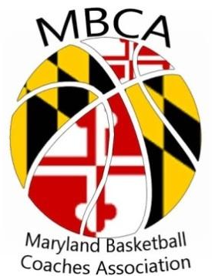
President: Teresa Waters
Vick President: Kathy Stoudt
Treasurer: Annie McGaha
Secretary: Rob Slopek
Director of Sponsorship: Barry Green

2019-2020
Membership Form

Membership Year
Until July 30, 2020

Name ___________________________________ School Name ____________________________________

Email (required) ___________________________ Classification of HS (1A, 2A, 3A, 4A) _______________

Mailing Address __________________________ County _________________________________________

City ___________________________ Zip _________________ Phone ______________________________

Coaching Level (For Current Season Only) REQUIRED (check all that apply)
___ Boys’ HS Head Varsity ___ Men’s College Head Coach ___Not Currently Coaching
___ Girls’ HS Head Varsity ___Men’s College Assistant Coach ___ Athletic Director
___Other Coaches (actively coaching) ___Women’s College Head Coach ___ Retired
___Women’s College Assistant Coach ___Other

SCHOOL MEMBERSHIP  ⬈ $150 for up to 10 coaches | HIGH SCHOOL VARSITY HEAD COACH OR COLLEGE HEAD COACH MEMBERSHIP  ⬈ $25 | MEMBERSHIP FOR ALL OTHER COACHING LEVELS  ⬈ $20

Make checks or money order payable to:
MBCA (Maryland Basketball Coaches Association)
Send payment and this entire form (one per coach) to:
MBCA
6718 Accipiter Drive
New Market, Maryland 21775
Email: mbcacommitte@gmail.com

